**Division F Tall Tale Contest 2017-2018**

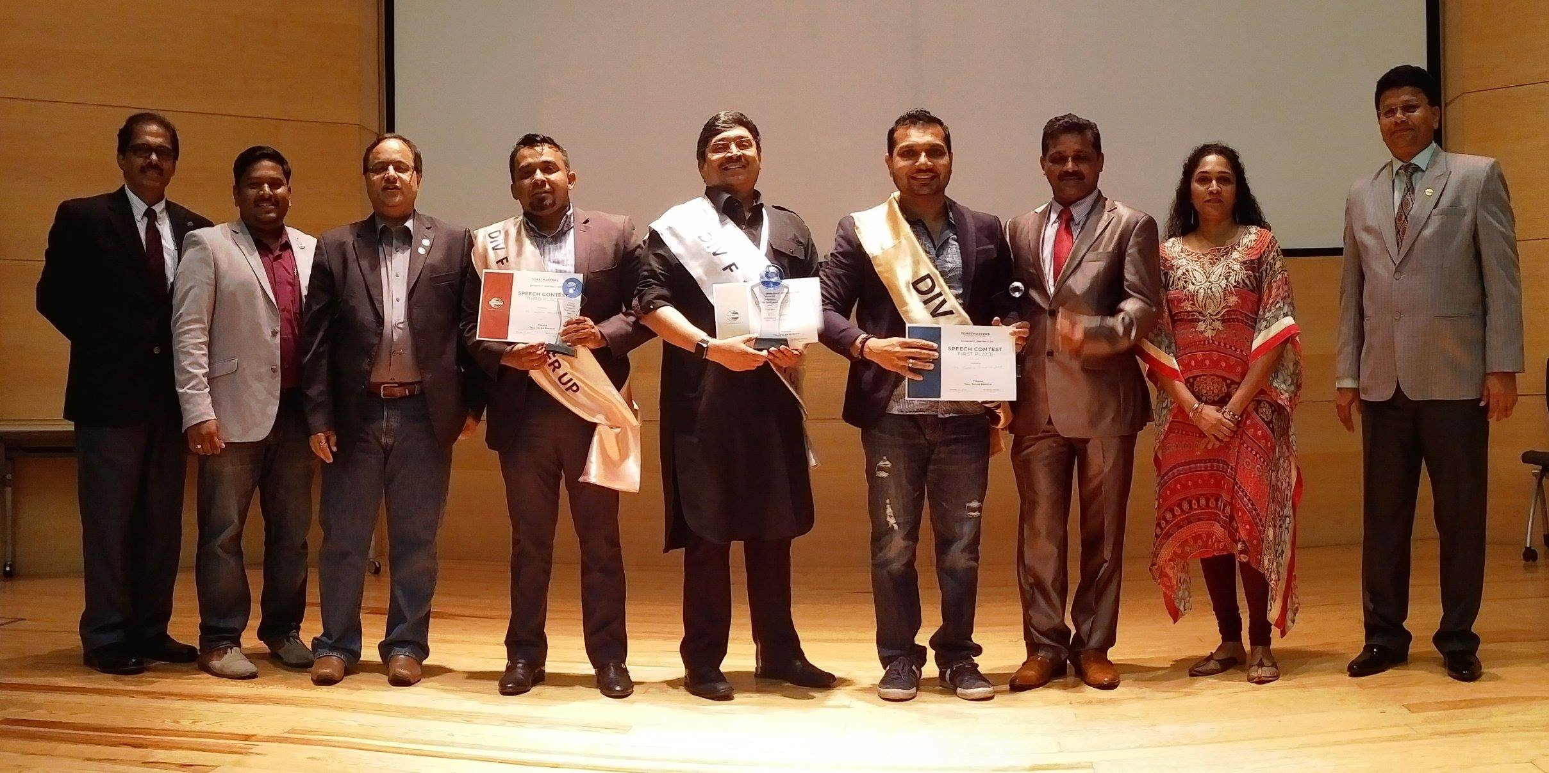

**Winners are: TM Suresh , TM Karthikeyan & TM Hashim Haleem**

